# CS 255 System Design Document – Jef DeWitt

## UML Diagrams

### UML Use Case Diagram

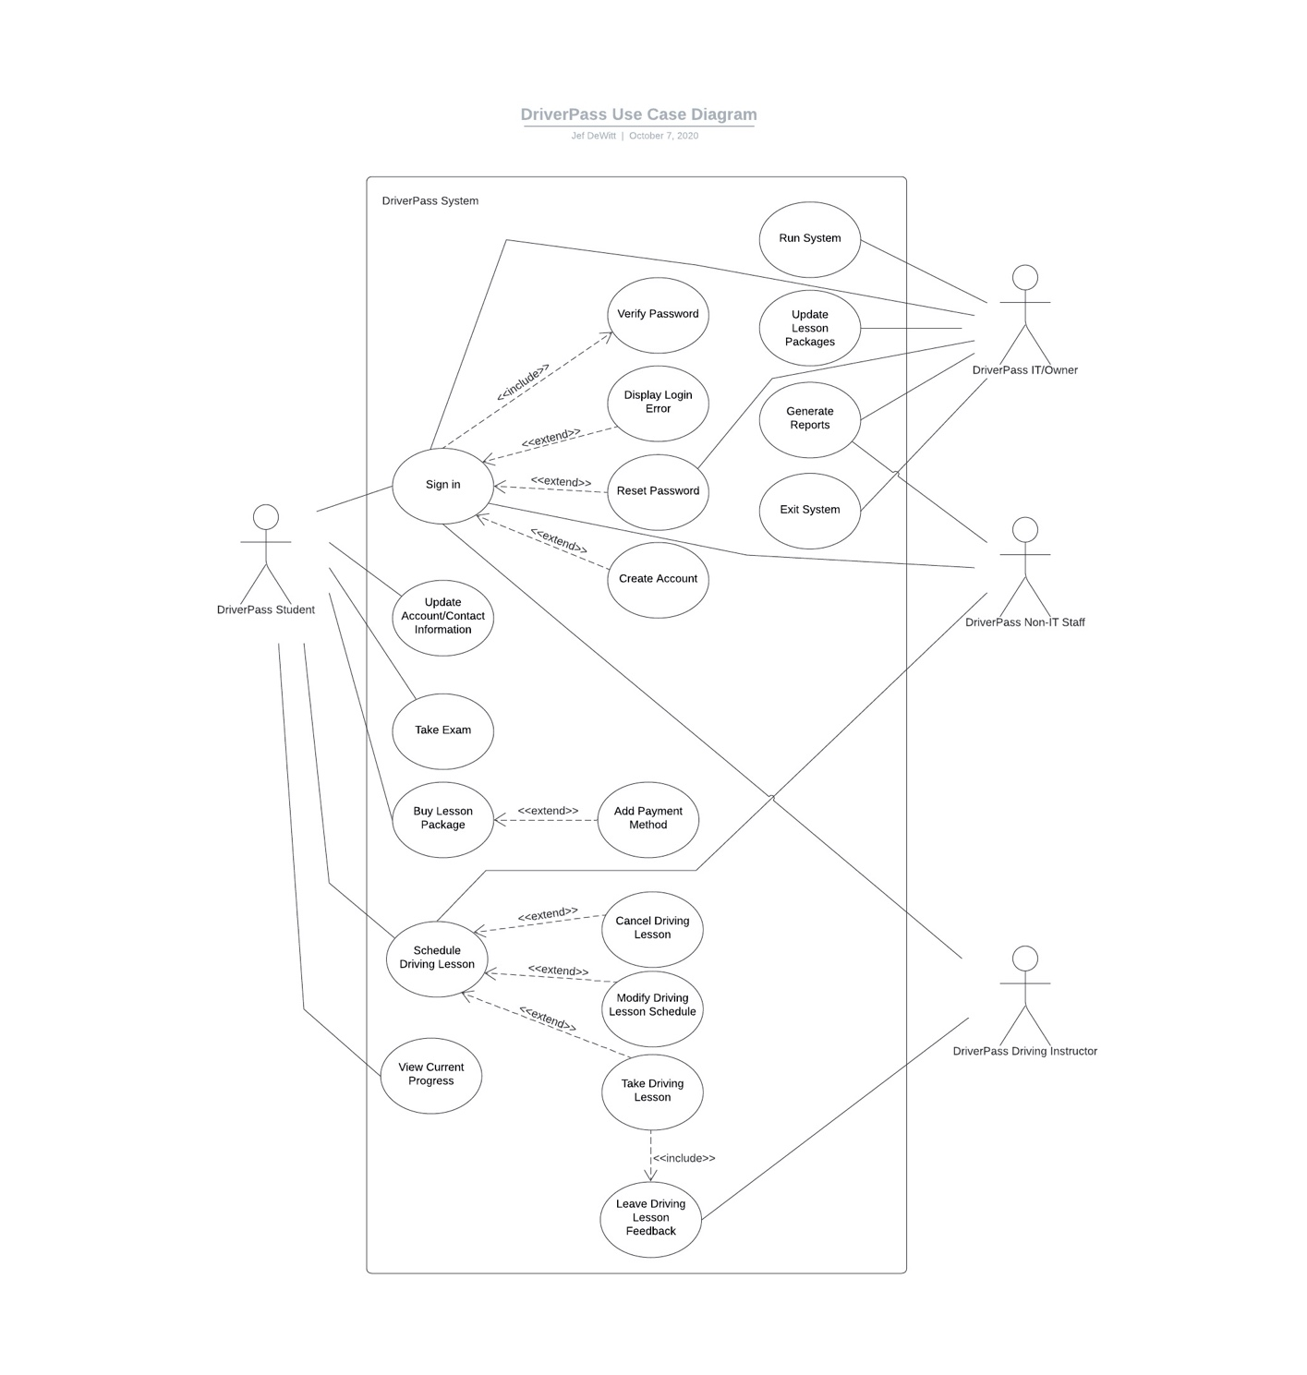

### UML Activity Diagrams

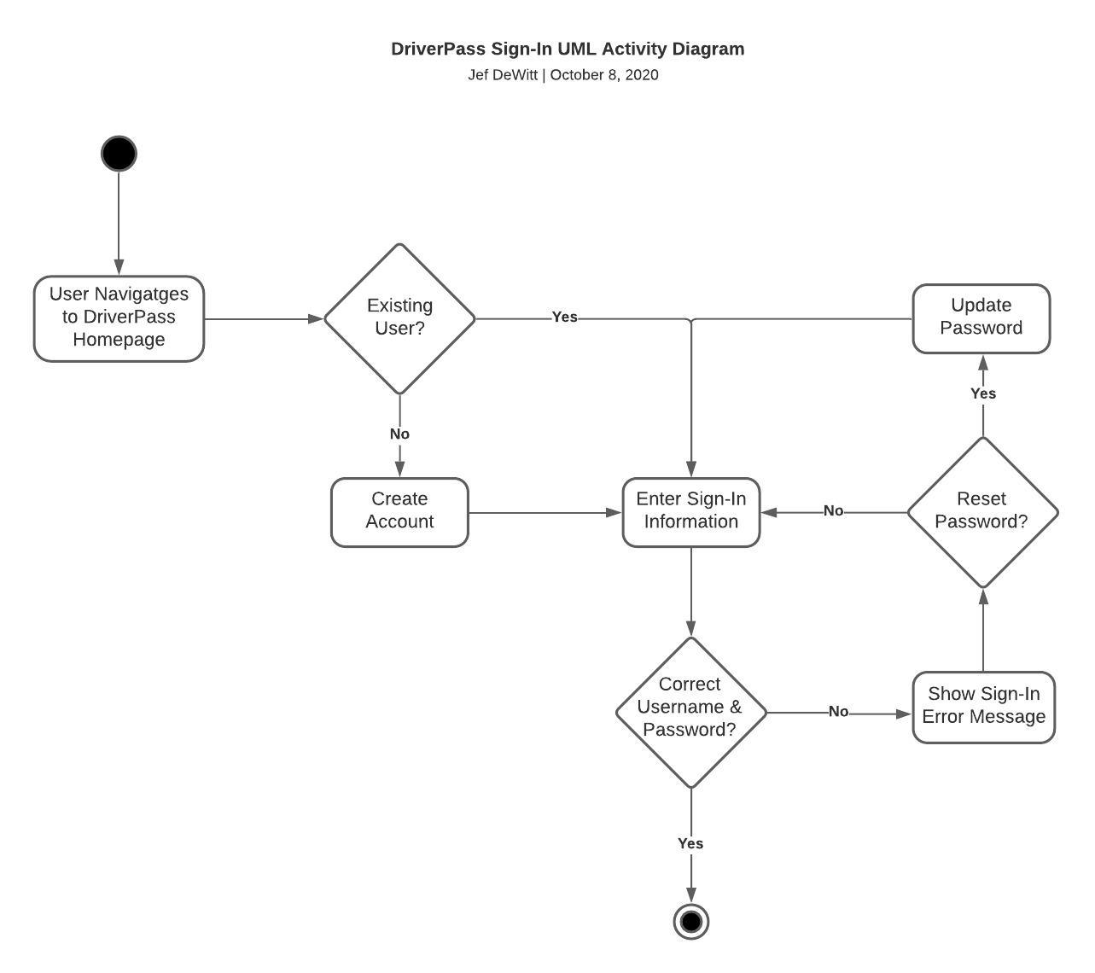

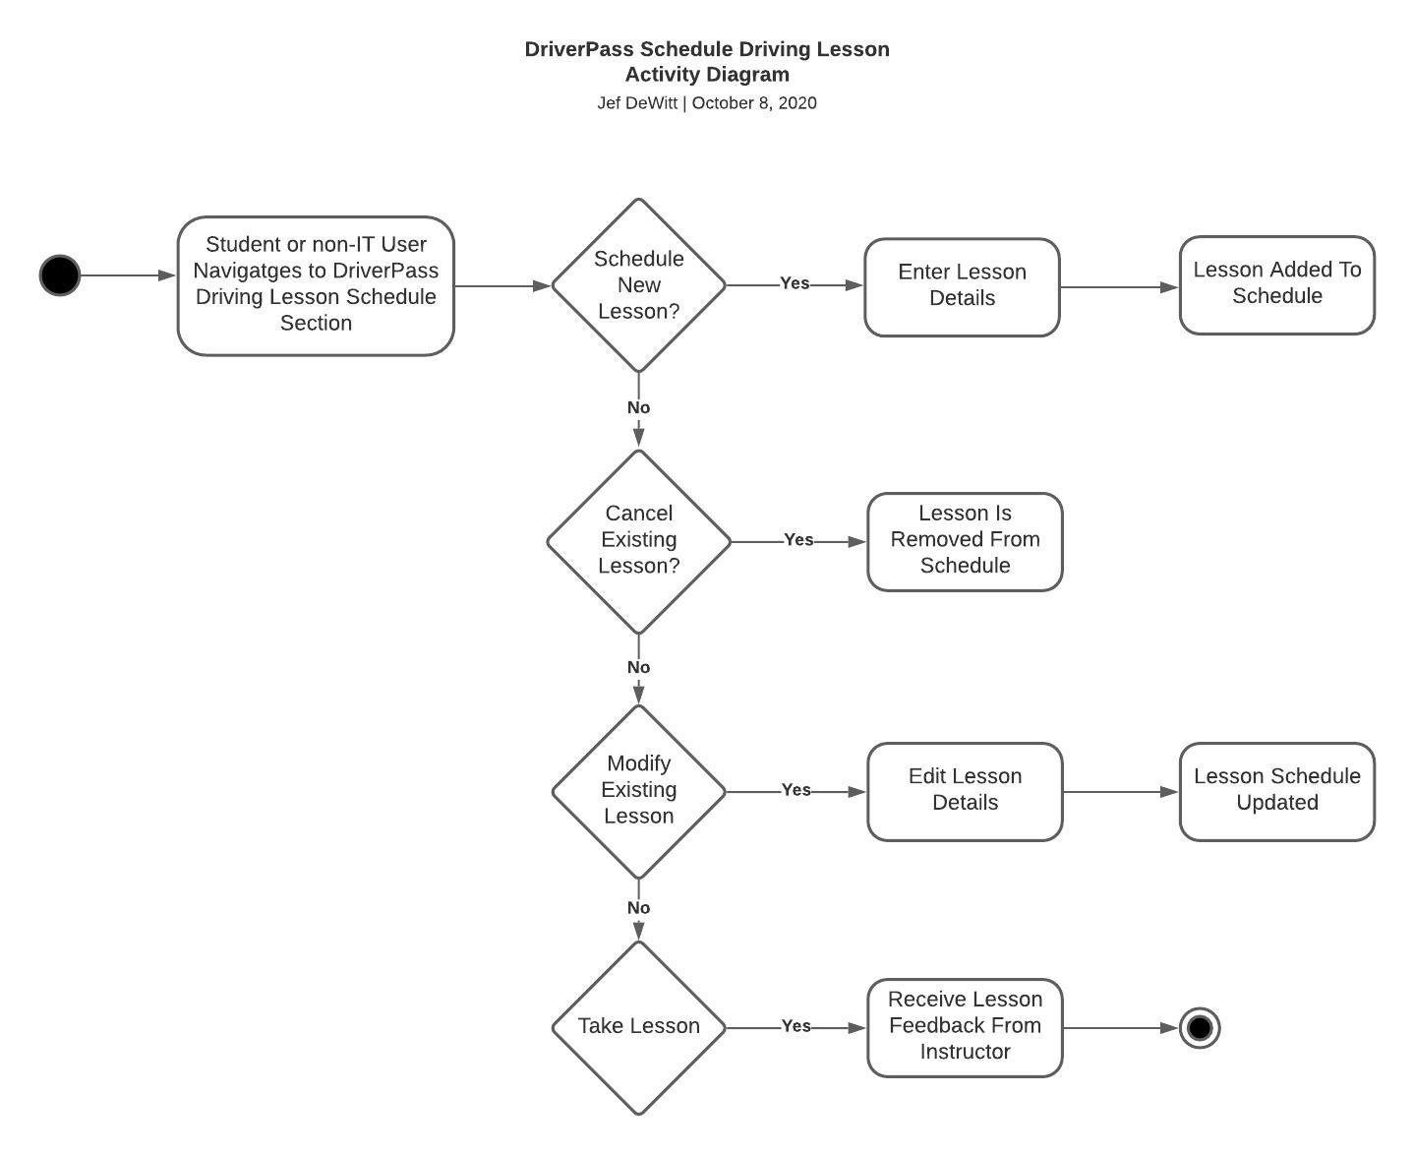

### UML Sequence Diagram

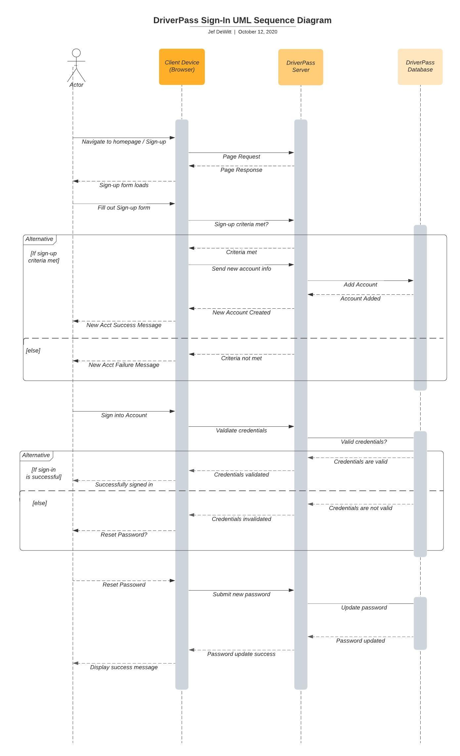

### UML Class Diagram

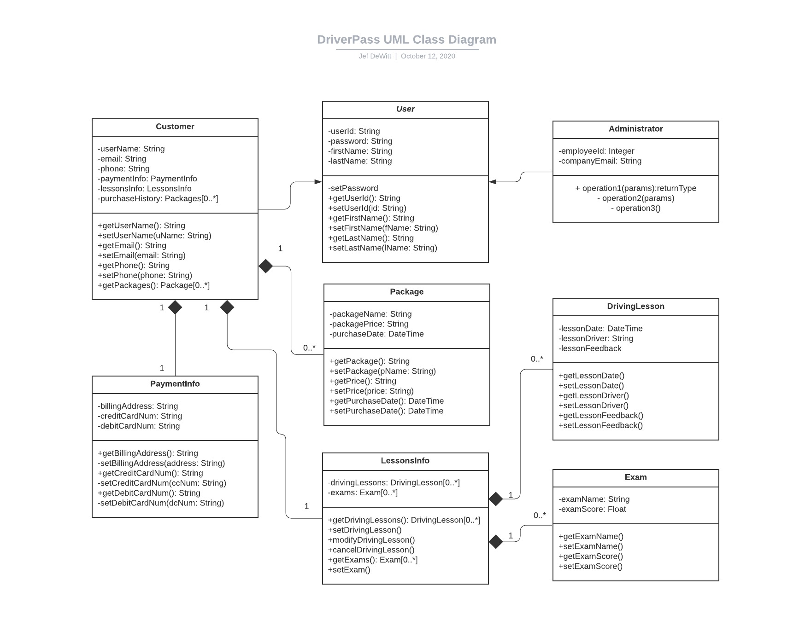

## Technical Requirements

Technical requirements for my system design are shown below:

* Hardware
  + Linux cloud servers serving various browser clients
  + Client devices running a modern web browser
    - Smart phone
    - Tablet
    - Laptop
    - Desktop
* Software
  + Latest security suites integration
  + Web-based distributed system, running on the Linux operating system
  + Supported browsers include:
    - Chrome
    - Edge
    - Firefox
    - Safari
  + Platform-agnostic: Will work on client devices running Mac, Linux and Windows operating systems
* Tools
  + Lucidchart models for the following:
    - UML Use Case diagram
    - UML Activity diagram for each use case
    - UML Sequence diagram for each activity
    - UML Class diagram for the entire system
  + Development environments (laptops/desktops and monitors)
  + Development stack that includes frontend, backend and database layers, along with continuous integration software, automated testing suites and VCS (Git).
  + Current IDE for development
    - Eclipse
    - IntelliJ
    - Visual Studio
* Infrastructure (needed for optimal system performance/delivery to client device)
  + High-speed Internet connection
    - Hardwire (ethernet)
    - WiFi
    - 4g/5g